Task No 01: Create a class student which contains the basic data about the student that takes the basic student data and displays it by using display method. An option of update is being provided to the user if he/she wants to update the data, the required data being updated.
Code:
Output:
Task No 02: Create a class “computer” which contains specifications of computer, the program shall ask the user does he/she wants to open the system, if the user press “yes” then the system starts shows the initial loading and then displays the basic configuration of a system (by calling the method of display () , update option is being provided by the user, values of the specified items are being updated once user decides to update that item.
Code:
Output:
Task No 03: Create a class of Employee which contains basic information about an employee, employee name, father’s name and salary etc. are being displayed by the display method and the salary of employees or the designation of the employees are being set/updated as per need.
Code:
Main:
package lab02task03;

public class Lab02task03 {

public static void main(String[] args) {
Employee e1 = new Employee();

e1.input();
e1.Display();
e1.Update();
e1.Display();
}
}

Employee:
package lab02task03;

import java.util.Scanner;

public class Employee {

static Scanner in = new Scanner(System.in);

String name, fName, designation;
int age, salary;
char rep;

public void input() {

System.out.println("Enter your Name:");
name = in.nextLine();
System.out.println("Enter your Father Name:");
fName = in.nextLine();
System.out.println("Enter your Designation:");
designation = in.nextLine();
System.out.println("Enter your Age");
age = in.nextInt();
System.out.println("Enter your Salary");
salary = in.nextInt();

}

public void Display() {

System.out.println("Name: " + name);
System.out.println("Father name: " + fName);
System.out.println("Designation: " + designation);
System.out.println("Age: " + age);
System.out.println("Salary: " + salary);

}

public void Update() {

System.out.println("Do you want to update any Data?");
System.out.println("Reply y for Yes, n for No.....");

rep = in.next().charAt(0);
if (rep == 'y' || rep == 'Y') {
System.out.println("Which of the following do you want to update?");
}
System.out.println("1) Designation\n2) Salary");
System.out.println("Reply with 1 or 2........");
int resp = in.nextInt();

switch (resp) {
case 1:
System.out.println("Enter your Designation:");
designation = in.nextLine();
break;
case 2:
System.out.println("Enter your Salary");
salary = in.nextInt();
break;
default:
System.out.println("\nInvalid Input! Please reply with 1 or 2........");
break;
}
}
}
Output:
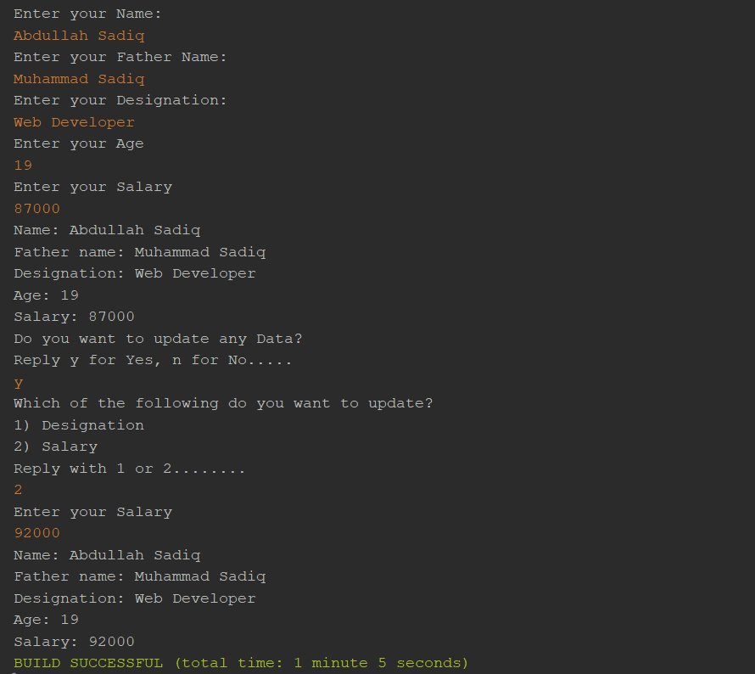
Task No 04: Create a class of Automobile which contains specifications of a car, check whether the car is in - ON/start state if not them asks the user if he/she want to start the car, If the car is already in start state then first display the current status of the car which includes the horse power, color, made, engine type etc. providing an option to the user if he/she wants to update any of the mentioned part from the car, if user selects “YES” then it is updated according to the need of the user, else the program will be ended.
Code:
Output:
Task No 05: Implement a class Car, that has the characteristics Brandname, PriceNew (which represents the price of the car when it was new), Color and Odometer (which is milo meter shows number of milage travelled by car). The class should have:
- A method getPriceAfterUse() which should return the price of the car after being used according to the following formula:
Car price after being used=priceNew*(1-(odometer/600,00))
- A method updateMilage (double travelled distance) that changes the current state of the car by increasing its milage.
- A method outputDetails() that will output to the screen all the information of the car, i.e. brandname, priceNew, priceused, color and odometer.
Code:
Output:

